**Online Figures**

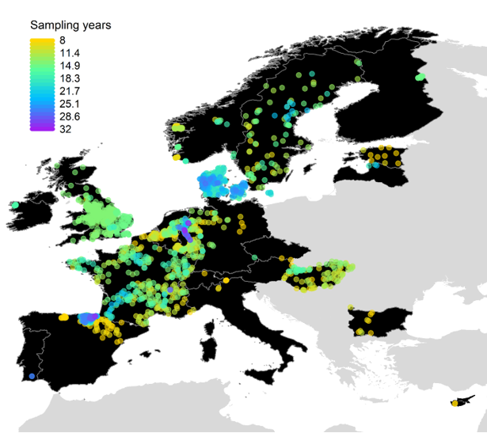

**Fig. 1 | Spatial variation in the number of sampling years across all 1,816 study sites.**

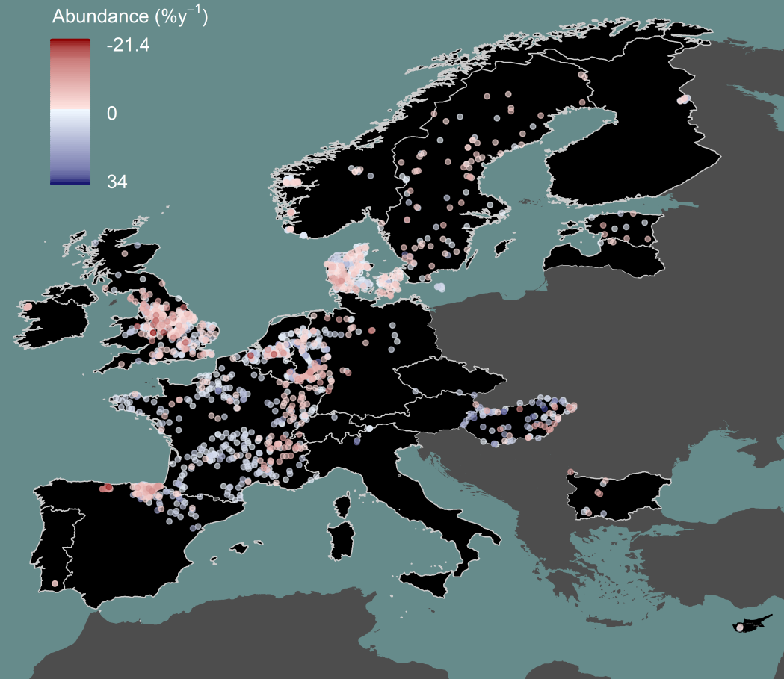

**Fig. 2 | Spatial distribution of abundance trends.** Point colors represent site-specific abundance trends in percentage change per year.

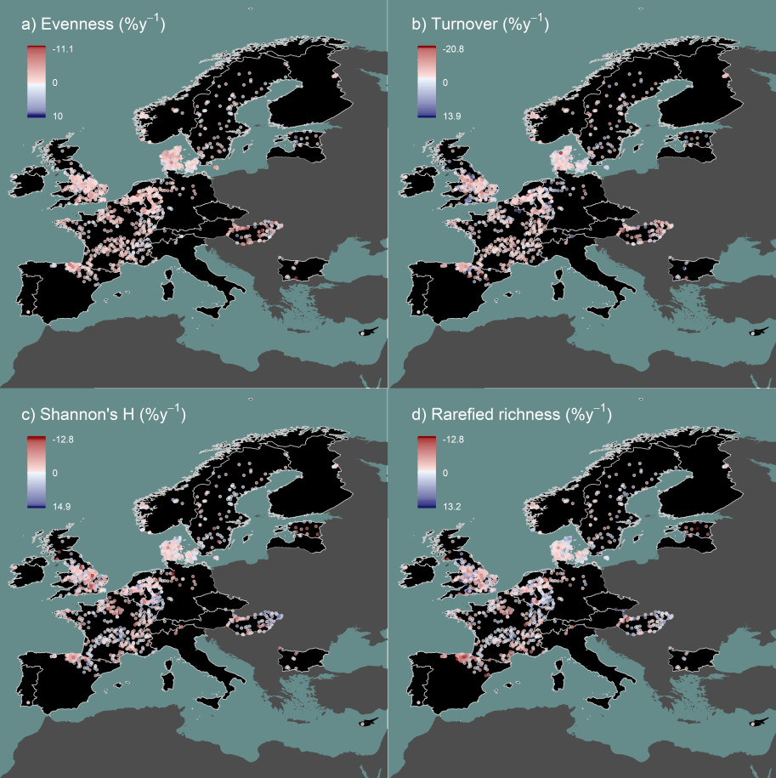

**Fig. 3 | Spatial distribution of trends in additional taxonomic diversity metrics..** Point colors represent site trends in percentage change per year for **a)** Shannon’s evenness, **b)** taxonomic turnover, **c)** Shannon’s diversity (H), and **d)** rarefied taxon richness.

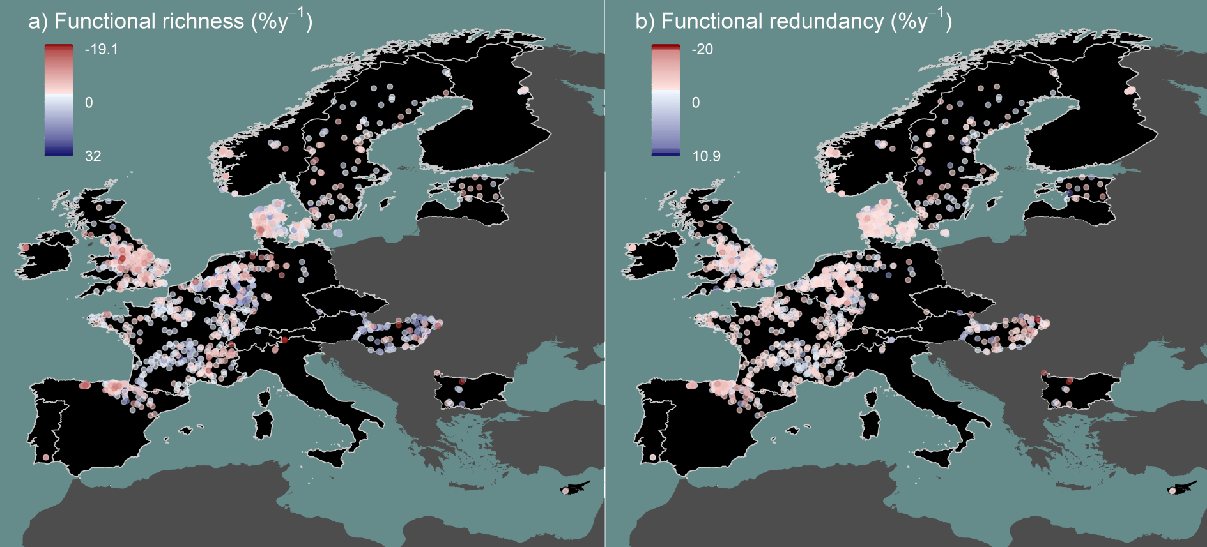

**Fig. 4 | Spatial distribution of trends in functional diversity metrics.** Point colors represent site trends in percentage change per year for **a)** functional richness and **b)** functional redundancy.

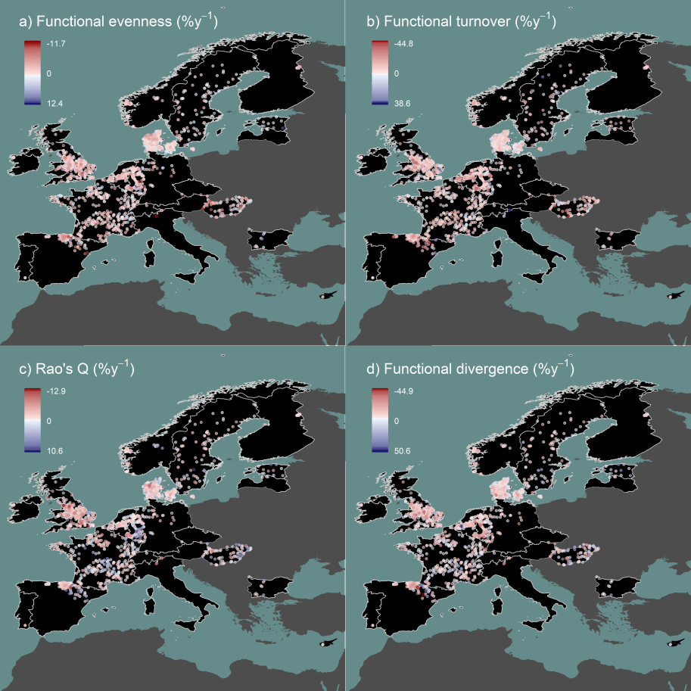

**Fig. 5 | Spatial distribution of trends in additional functional diversity metrics..** Point colors represent site trends in percentage change per year for **a)** functional evenness, **b)** functional turnover, **c)** Rao’s quadratic entropy, and **d)** functional divergence.

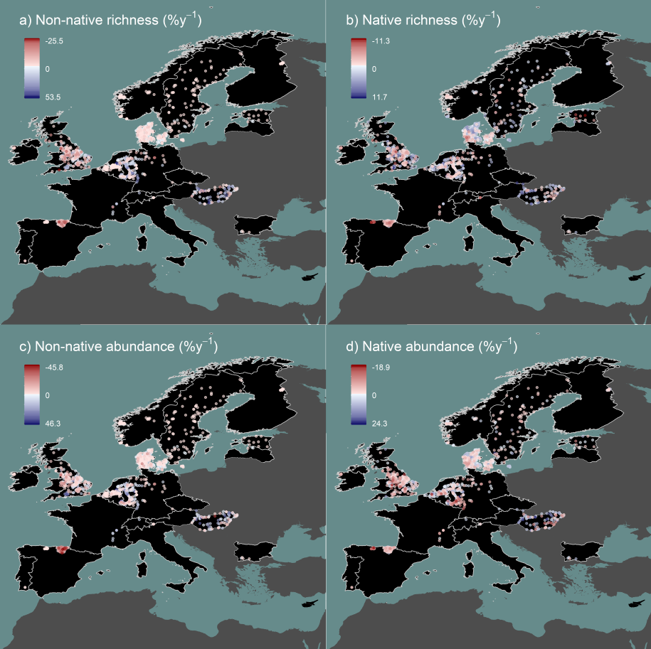

**Fig. 6 | Spatial distribution of trends in non-native and native species.** Point colors represent site trends in percentage change per year for **a)** non-native taxon richness, **b)** native taxon richness, **c)** non-native abundance, and **d)** native abundance. Only the 1,299 sites having high taxonomic resolution enabling identification of native versus non-native species are shown.

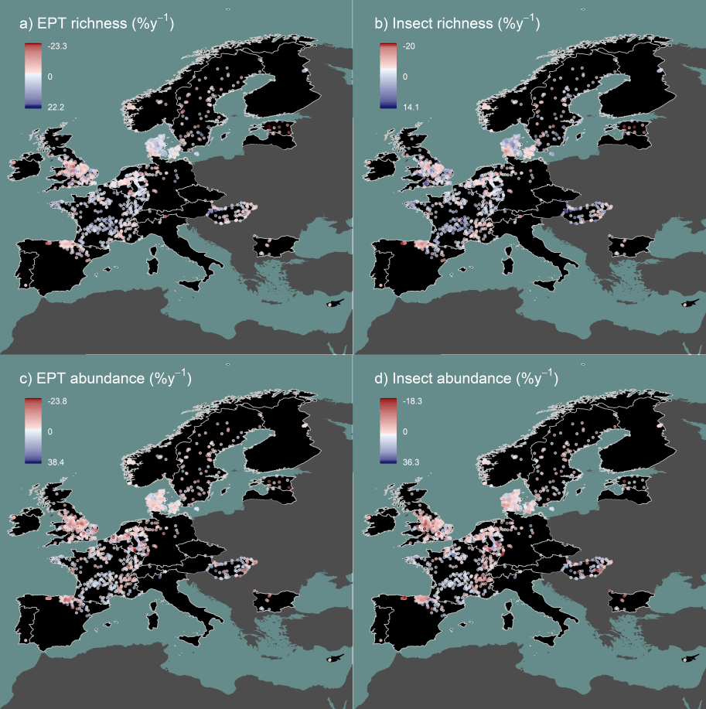

**Fig. 7 | Spatial distribution of trends in EPT and insect taxa.** Point colors represent site trends in percentage change per year for **a)** EPT taxon richness, **b)** insect taxon richness, **c)** EPT abundance, and **d)** insect abundance.

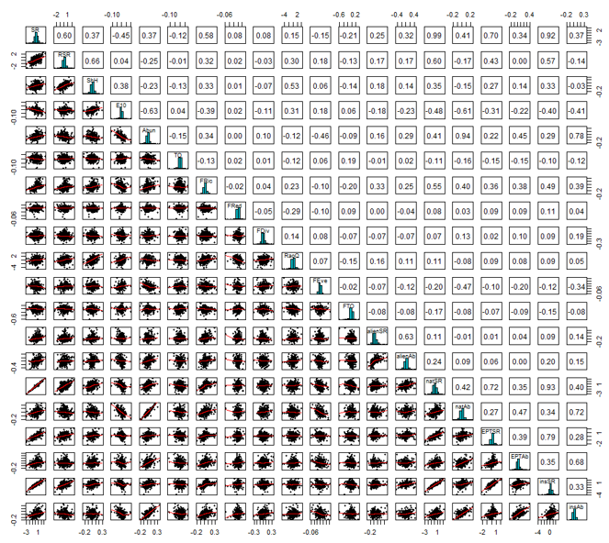

**Fig. 8 | Pearson’s correlations, histograms, and regression plots comparing all response variables.** SR = taxon richness, RSR = rarefied taxon richness, ShH = Shannon’s diversity (H), E10 = Shannon’s evenness, Abund = abundance, TO = taxonomic turnover, FRic = functional richness, FRed = functional redundancy, FDiv = functional divergence, RaoQ = Rao’s quadratic entropy, FEve = functional evenness, FTO = functional turnover, alienSR = non-native species richness, alienAb = non-native abundance, natSR = native taxon richness, natAb = native abundance, EPTSR = EPT taxon richness, EPTAb = EPT abundance, insSR = insect taxon richness, and insAb = insect abundance.

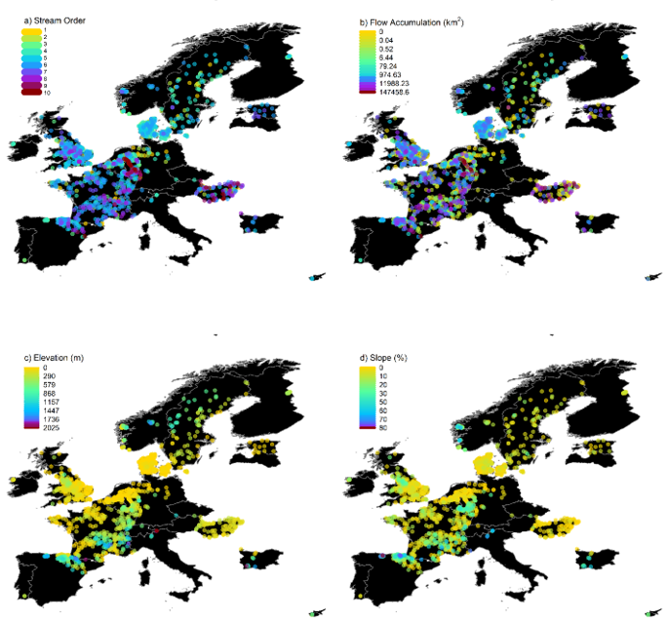

**Fig. 9 | Distribution of stream characteristics.** Spatial variation across the 1,816 study sites in **a)** Strahler stream order, **b)** flow accumulation, **c)** elevation, and **d)** slope. See Extended Data Table 4 for more details and sources of environmental data.

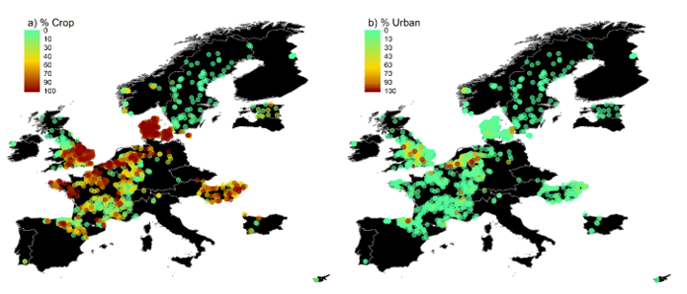

**Fig. 10 | Distribution of land cover.** Spatial variation across the 1,816 study sites in percentage upstream **a)** crop and **b)** urban land cover types. See Extended Data Table 4 for details and sources of environmental data.

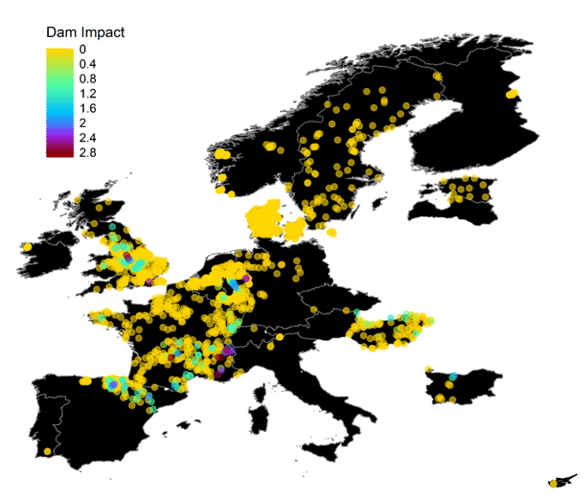

**Fig. 11 | Distribution of dam impacts.** Spatial variation across the 1,816 study sites in dam impact score based on distances between sites and upstream dams. See Extended Data Table 4 for details and the source of dam data and Methods for calculation of dam impact scores.

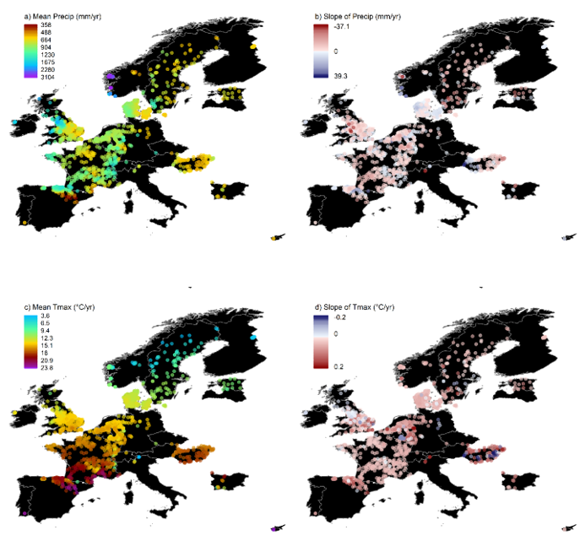

**Fig. 12 | Distribution of climate variation.** Spatial variation across the 1,816 sites and over study duration for **a)** mean cumulative annual precipitation, **b)** the change (trend) in annual precipitation per year, **c)** mean annual maximum temperature, and **d)** the change (trend) in annual mean maximum temperature per year. See Extended Data Table 4 for details and sources of climate data and the Methods for additional description of the calculations.

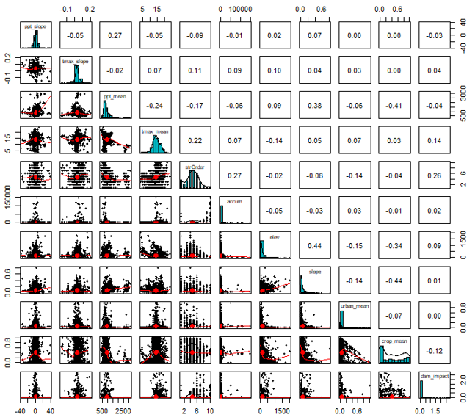

**Fig. 13 | Pearson’s correlations, histograms, and regression plots comparing all stream characteristics and environmental driver variables.** ppt_slope = the change (trend) in annual precipitation per year, tmax_slope = the change (trend) in annual mean maximum temperature per year, ppt_mean = mean annual cumulative precipitation, tmax_mean = mean annual maximum temperature, strOrder = Strahler stream order, accum = flow accumulation, elev = elevation, slope = slope, urban_mean = percentage upstream urban land cover, crop_mean = percentage upstream crop land cover, dam_impact = dam impact score. See Extended Data Table 4 and Methods for additional information on environmental data sources and processing.

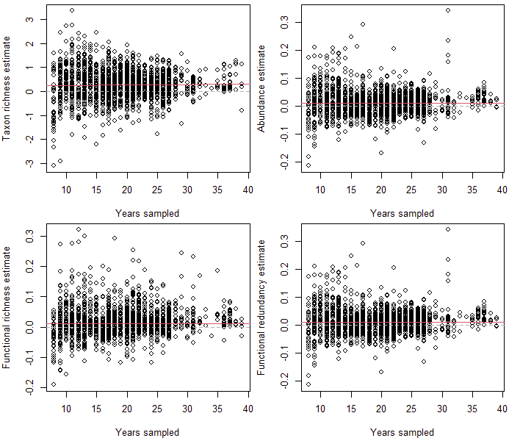

**Fig. 14 | Sensitivity check to examine effects of years sampled on biodiversity trend estimates.** Grey dashed lines mark a trend of zero and red solid lines show linear regressions relationships between years sampled and estimates.

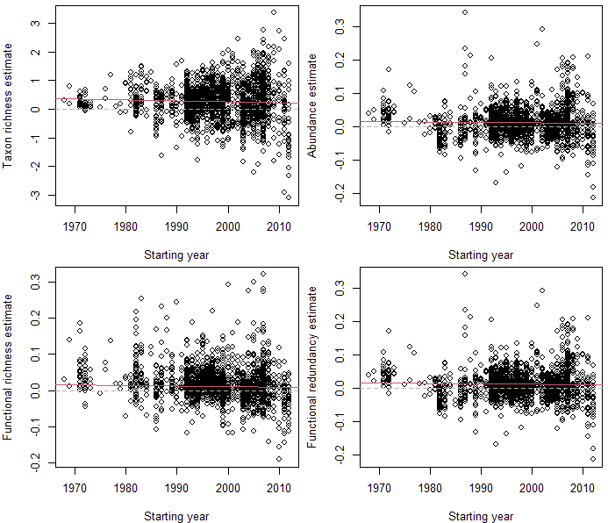

**Fig. 15 | Sensitivity check to examine effects of the first sampling year (start year) on biodiversity trend estimates.** Grey dashed lines mark a trend of zero and red solid lines show linear regressions relationships between start year and estimates.



**Fig. 17 |**